Day-11
Task 1:
What is an Actuator in Spring boot?
Spring Boot Actuator is a module that provides production-ready features to monitor and manage a Spring Boot application.
Task 2:
Advantages of Actuator
• Health Monitoring
- Checks whether the application is UP or DOWN.
• Application Metrics
- Displays CPU usage, memory usage, request count, JVM statistics, etc.
• Production Monitoring
- Helps monitor live applications.
• Easy Troubleshooting
- Identifies issues quickly using endpoints.
• Built-in Endpoints
- No need to write monitoring code manually.
• Integration
- Easily integrates with monitoring tools like:
  - Prometheus
  - Grafana
  - ELK Stack
  - Micrometer
• Security Support
- Sensitive endpoints can be secured using Spring Security.

Task 3:
What are the commonly used Actuator end points?
Endpoint | Purpose
/actuator | Lists all available endpoints
/actuator/health | Shows application health
/actuator/info | Displays application information
/actuator/beans | Lists all Spring beans
/actuator/env | Shows environment properties
/actuator/metrics | Displays application metrics
/actuator/mappings | Shows all request mappings
/actuator/loggers | Displays logger information
/actuator/threaddump | Shows JVM thread dump
/actuator/heapdump | Generates heap dump
/actuator/caches | Shows cache details
/actuator/scheduledtasks | Displays scheduled tasks

Task 4:
Create a Small demo of Actuator to know the functionality
package com.example.Actuator.controller;
import org.springframework.web.bind.annotation.GetMapping;
import org.springframework.web.bind.annotation.RestController;
@RestController
public class DemoController {
@GetMapping("/")
public String home() {
return "Welcome to Spring Boot Actuator Demo";
}
}

spring.application.name=Actuator
management.endpoints.web.exposure.include=*
management.endpoint.health.show-details=always

<?xml version="1.0" encoding="UTF-8"?>
<project xmlns="http://maven.apache.org/POM/4.0.0" xmlns:xsi="http://www.w3.org/2001/XMLSchema-instance"
xsi:schemaLocation="http://maven.apache.org/POM/4.0.0 https://maven.apache.org/xsd/maven-4.0.0.xsd">
<modelVersion>4.0.0</modelVersion>
<parent>
<groupId>org.springframework.boot</groupId>
<artifactId>spring-boot-starter-parent</artifactId>
<version>4.1.0</version>
<relativePath/> <!-- lookup parent from repository -->
</parent>
<groupId>com.example</groupId>
<artifactId>Actuator</artifactId>
<version>0.0.1-SNAPSHOT</version>
<name/>
<description/>
<url/>
<licenses>
<license/>
</licenses>
<developers>
<developer/>
</developers>
<scm>
<connection/>
<developerConnection/>
<tag/>
<url/>
</scm>
<properties>
<java.version>26</java.version>
</properties>
<dependencies>
<dependency>
<groupId>org.springframework.boot</groupId>
<artifactId>spring-boot-starter-actuator</artifactId>
</dependency>
<dependency>
<groupId>org.springframework.boot</groupId>
<artifactId>spring-boot-starter-webmvc</artifactId>
</dependency>
<dependency>
<groupId>org.springframework.boot</groupId>
<artifactId>spring-boot-starter-actuator-test</artifactId>
<scope>test</scope>
</dependency>
<dependency>
<groupId>org.springframework.boot</groupId>
<artifactId>spring-boot-starter-webmvc-test</artifactId>
<scope>test</scope>
</dependency>
<dependency>
<groupId>org.springframework.boot</groupId>
<artifactId>spring-boot-starter-web</artifactId>
</dependency>
</dependencies>
<build>
<plugins>
<plugin>
<groupId>org.springframework.boot</groupId>
<artifactId>spring-boot-maven-plugin</artifactId>
</plugin>
</plugins>
</build>
</project>

Task 5:
What is Spring Security Architecture?
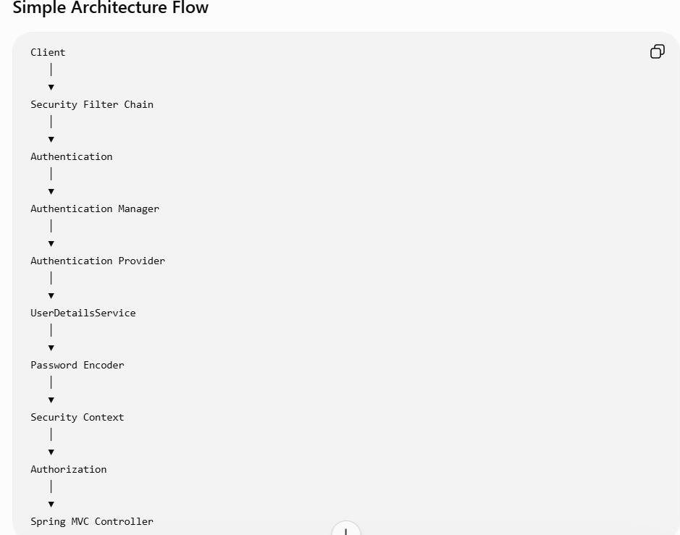
Task-6
What are the core components of Spring Security Architecture?
The core components of Spring Security Architecture are:
Component | Description
Security Filter Chain | Intercepts every incoming HTTP request and applies security checks.
Authentication Manager | Coordinates the authentication process.
Authentication Provider | Validates user credentials.
UserDetailsService | Loads user details from a database or another source.
PasswordEncoder | Encrypts and verifies passwords securely.
SecurityContext | Stores the authenticated user's details during the request.
Authentication Object | Holds user credentials and authorities.
Authorization Manager | Determines whether the authenticated user has permission to access a resource.

Task 7: Diagrammatic Representation of Spring Security Architecture
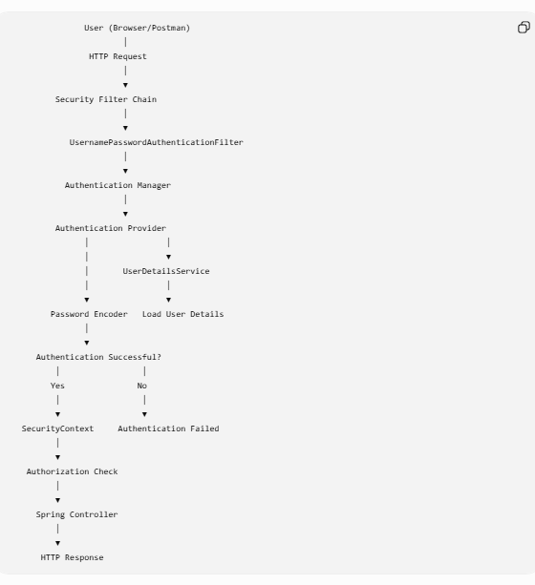

Task 8: What is a Security Filter Chain? Give example code?
Definition
A Security Filter Chain is a sequence of security filters that intercept every HTTP request before it reaches the controller. It performs authentication, authorization, CSRF protection, session management, and more.

@Configuration
@EnableWebSecurity
public class SecurityConfig {

@Bean
public SecurityFilterChain securityFilterChain(HttpSecurity http)
throws Exception {

http
.authorizeHttpRequests(auth -> auth
.requestMatchers("/login").permitAll()
.requestMatchers("/admin/**").hasRole("ADMIN")
.anyRequest().authenticated()
)
.formLogin();

return http.build();
}
}
Task-9
What is an Authentication Manager? Give example code
Definition
The AuthenticationManager is responsible for authenticating users. It delegates authentication to one or more AuthenticationProvider implementations.
Example
@Autowired
AuthenticationManager authenticationManager;

Authentication authentication =
authenticationManager.authenticate(
new UsernamePasswordAuthenticationToken(
"john",
"password123"
)
);
Task 10: What are Authentication Providers? Give example and code
Definition
An AuthenticationProvider validates user credentials. Spring Security can use different providers such as:
- Database authentication
- LDAP
- OAuth2
- JWT
- In-memory authentication
Example
@Bean
public AuthenticationProvider authenticationProvider() {

DaoAuthenticationProvider provider =
new DaoAuthenticationProvider();

provider.setUserDetailsService(userDetailsService());
provider.setPasswordEncoder(passwordEncoder());

return provider;
}

Task 11: What is UserDetailsService? Give example
Definition
UserDetailsService is an interface that loads user information from a database or any other storage.
@Service
public class MyUserDetailsService
implements UserDetailsService {

@Override
public UserDetails loadUserByUsername(
String username)
throws UsernameNotFoundException {

return User.builder()
.username("admin")
.password("$2a$10...")
.roles("ADMIN")
.build();
}
}
Task 12: What is PasswordEncoder? Give example
Definition
A PasswordEncoder encrypts passwords before storing them and verifies passwords during login.
The most commonly used implementation is BCryptPasswordEncoder.
Configuration
@Bean
public PasswordEncoder passwordEncoder() {
return new BCryptPasswordEncoder();
}
Encoding
String encoded =
passwordEncoder.encode("password123");
Verification
passwordEncoder.matches(
"password123",
encoded
);

Task 13: What is SecurityContext?
Definition
The SecurityContext stores information about the currently authenticated user throughout the request
Task 14: Spring Security Internal Functionality (Step by Step)
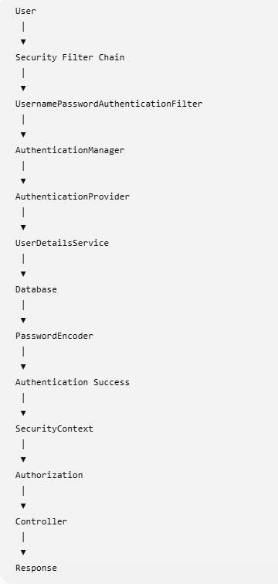

Task 15: What is Thymeleaf? Explain. Why is it used
Definition
Thymeleaf is a Java-based server-side template engine used to build dynamic web pages in Spring Boot applications.
It combines HTML with data from the backend to generate dynamic content.

Task 16: Create a Demo on Thymeleaf

package com.example.Thymleaf.controller;
import org.springframework.stereotype.Controller;
import org.springframework.ui.Model;
import org.springframework.web.bind.annotation.GetMapping;
@Controller
public class HomeController{
@GetMapping("/")
public String home(Model model){
model.addAttribute("name","Nagurvali");
return "home";
}
}

<!DOCTYPE html>
<html xmlns:th="http://www.thymeleaf.org">
<head>
<title>Thymeleaf Demo</title>
</head>
<body>
<h1>Welcome to Thymeleaf</h1>
<h2 th:text="${name}"></h2>
</body>
</html>

Task 17: Advantages of Thyme leaf
- Easy integration with Spring Boot.
- Uses standard HTML.
- Supports reusable layouts.
- Supports form validation.
- Secure against common template injection issues.
- Easy debugging.
- Better readability.
- Rich expression language.
- SEO-friendly HTML.
- Lightweight and easy to maintain.

Task 17: Advantages of Thymeleaf (10.26 – 10.30)
- Easy integration with Spring Boot.
- Uses standard HTML.
- Supports reusable layouts.
- Supports form validation.
- Secure against common template injection issues.
- Easy debugging.
- Better readability.
- Rich expression language.
- SEO-friendly HTML.
- Lightweight and easy to maintain.

Task 18: What is Caching in Spring Boot?
Definition
Caching is a technique used to store frequently accessed data temporarily in memory so future requests can retrieve it quickly without repeatedly querying the database or executing expensive operations.
Benefits
- Faster response time
- Reduced database load
- Better performance
- Lower CPU usage
- Improved scalability

Task 19: What are the Features of Spring Boot?
- Auto Configuration
- Starter Dependencies
- Embedded Servers (Tomcat, Jetty, Undertow)
- Spring Boot Actuator
- Spring Boot CLI
- Externalized Configuration
- Rapid Application Development
- Minimal XML Configuration
- Production-ready Features
- DevTools for automatic restart and live reload
- Easy Microservices Development
- Seamless integration with Spring modules

Task 20: Types of Caching
Cache Type | Explanation
In-Memory Cache | Stores data in application memory (e.g., ConcurrentHashMap, Caffeine). Fastest access but data is lost when the application stops.
Distributed Cache | Shared across multiple application instances (e.g., Redis, Hazelcast). Suitable for clustered deployments.
Database Cache | Frequently accessed query results are cached to reduce repeated database access.
Disk Cache | Stores cached data on disk, allowing persistence across restarts but slower than memory.
Client-Side Cache | Cached in the browser or client application to reduce repeated server requests.

Task 21: Spring Boot Caching Annotations with
Annotation | Usage
@EnableCaching | Enables caching support in the application.
@Cacheable | Stores the method result in the cache.
@CachePut | Updates the cache every time the method is executed.
@CacheEvict | Removes one or more entries from the cache.
@Caching | Combines multiple caching operations on a single method.
@CacheConfig | Defines common cache configuration at the class level.

Mockito Code Cecking

package com.example.Mockito.repository;
import com.example.Mockito.model.BankAccount;
public interface BankRepository {
BankAccount findByAccountNumber(String accountNumber);
void save(BankAccount account);
}

package com.example.Mockito.service;
import com.example.Mockito.model.BankAccount;
import com.example.Mockito.repository.BankRepository;
import org.springframework.stereotype.Service;
@Service
public class BankService {
private final BankRepository repository;
public BankService(BankRepository repository) {
this.repository = repository;
}
public void deposit(String accountNumber, double amount) {
BankAccount account = repository.findByAccountNumber(accountNumber);
account.setBalance(account.getBalance() + amount);
repository.save(account);
}
public void withdraw(String accountNumber, double amount) {
BankAccount account = repository.findByAccountNumber(accountNumber);
if (account.getBalance() < amount) {
throw new IllegalArgumentException("Insufficient funds");
}
account.setBalance(account.getBalance() - amount);
repository.save(account);
}
}

<?xml version="1.0" encoding="UTF-8"?>
<project xmlns="http://maven.apache.org/POM/4.0.0" xmlns:xsi="http://www.w3.org/2001/XMLSchema-instance"
xsi:schemaLocation="http://maven.apache.org/POM/4.0.0 https://maven.apache.org/xsd/maven-4.0.0.xsd">
<modelVersion>4.0.0</modelVersion>
<parent>
<groupId>org.springframework.boot</groupId>
<artifactId>spring-boot-starter-parent</artifactId>
<version>4.1.0</version>
<relativePath/> <!-- lookup parent from repository -->
</parent>
<groupId>com.example</groupId>
<artifactId>Mockito</artifactId>
<version>0.0.1-SNAPSHOT</version>
<name/>
<description/>
<url/>
<licenses>
<license/>
</licenses>
<developers>
<developer/>
</developers>
<scm>
<connection/>
<developerConnection/>
<tag/>
<url/>
</scm>
<properties>
<java.version>26</java.version>
</properties>
<dependencies>
<dependency>
<groupId>org.springframework.boot</groupId>
<artifactId>spring-boot-starter-webmvc</artifactId>
</dependency>
<dependency>
<groupId>org.springframework.boot</groupId>
<artifactId>spring-boot-starter-webmvc-test</artifactId>
<scope>test</scope>
</dependency>
</dependencies>
<build>
<plugins>
<plugin>
<groupId>org.springframework.boot</groupId>
<artifactId>spring-boot-maven-plugin</artifactId>
</plugin>
</plugins>
</build>
</project>

package com.example.Mockito.service;
import com.example.Mockito.model.BankAccount;
import com.example.Mockito.repository.BankRepository;
import org.junit.jupiter.api.Test;
import org.junit.jupiter.api.extension.ExtendWith;
import org.mockito.InjectMocks;
import org.mockito.Mock;
import org.mockito.junit.jupiter.MockitoExtension;
import static org.junit.jupiter.api.Assertions.*;
import static org.mockito.Mockito.*;
@ExtendWith(MockitoExtension.class)
class BankServiceTest {
@Mock
private BankRepository repository;
@InjectMocks
private BankService service;
@Test
void testDeposit() {
BankAccount account = new BankAccount("123", 500);
when(repository.findByAccountNumber("123"))
.thenReturn(account);
service.deposit("123", 200);
assertEquals(700, account.getBalance());
verify(repository).save(account);
}
@Test
void testWithdrawSuccess() {
BankAccount account = new BankAccount("123", 500);
when(repository.findByAccountNumber("123"))
.thenReturn(account);
service.withdraw("123", 200);
assertEquals(300, account.getBalance());
verify(repository).save(account);
}
@Test
void testWithdrawInsufficientFunds() {
BankAccount account = new BankAccount("123", 100);
when(repository.findByAccountNumber("123"))
.thenReturn(account);
Exception ex = assertThrows(
IllegalArgumentException.class,
() -> service.withdraw("123", 200)
);
assertEquals("Insufficient funds", ex.getMessage());
verify(repository, never()).save(account);
}
}

Task 22: What do you think @InjectMocks annotation does?
@InjectMocks is a Mockito annotation used to create an instance of the class being tested and automatically inject the mock objects created using @Mock or @Spy into it. It helps test a class without manually creating its dependencies.
@Mock
private BankRepository repository;

@InjectMocks
private BankService service;
Here, Mockito creates a BankService object and injects the mocked BankRepository into it.

Task 23: Write about @Spy annotation and explain the functionality with a small piece of code.
@Spy is used to create a partial mock of a real object. Unlike @Mock, a spy calls the actual methods unless they are explicitly stubbed.
Example:
import static org.mockito.Mockito.*;

List<String> list = spy(new ArrayList<>());

list.add("Java"); // Calls real method
when(list.size()).thenReturn(10);

System.out.println(list.get(0)); // Output: Java
System.out.println(list.size()); // Output: 10
Explanation:
The real add() method is executed, but the size() method is mocked to return 10

Task 24: Why is @Mock annotation used?
@Mock is used to create a fake object of a class or interface. It replaces real dependencies so that unit tests focus only on the class being tested without accessing databases, APIs, or external services.
Example:
@Mock
private BankRepository repository;
Here, BankRepository is mocked, so no actual database operations are performed.

Task 25: What is Partial Mocking? Which annotation is used for partial mocking?
Partial mocking means some methods of an object execute their real implementation, while other methods are mocked.
The annotation used for partial mocking is:
@Spy
Example:
@Spy
ArrayList<String> list = new ArrayList<>();

list.add("Spring"); // Real method

Task 26: For the code given, what is verify() used for and why do we use it?
verify() is a Mockito method used to check whether a mocked object's method was called during test execution. It helps ensure that interactions with dependencies happen as expected.
Example:
verify(repository).save(account);
This verifies that the save() method of repository was called once with the given account.
You can also use:
verify(repository, never()).save(account);
This verifies that the save() method was never called.

Task 27: List down a few more annotations that we use for mocking.
Common Mockito annotations include:
- @Mock – Creates a mock object.
- @Spy – Creates a partial mock of a real object.
- @InjectMocks – Creates the class under test and injects mock objects into it.
- @Captor – Captures method arguments for verification.
- @ExtendWith(MockitoExtension.class) – Enables Mockito annotations in JUnit 5 tests.
- @MockitoSettings – Configures Mockito behavior, such as strictness, for a test class.
These annotations simplify writing clean and maintainable unit tests with Mockito.

